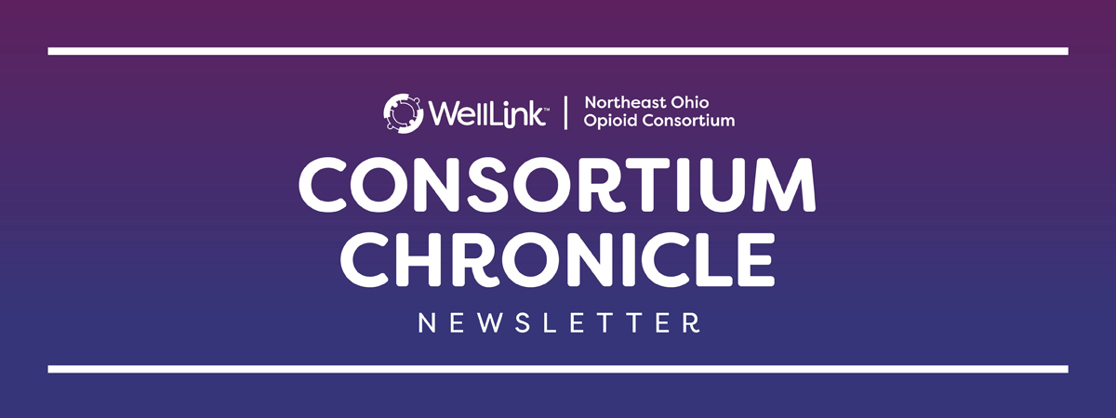
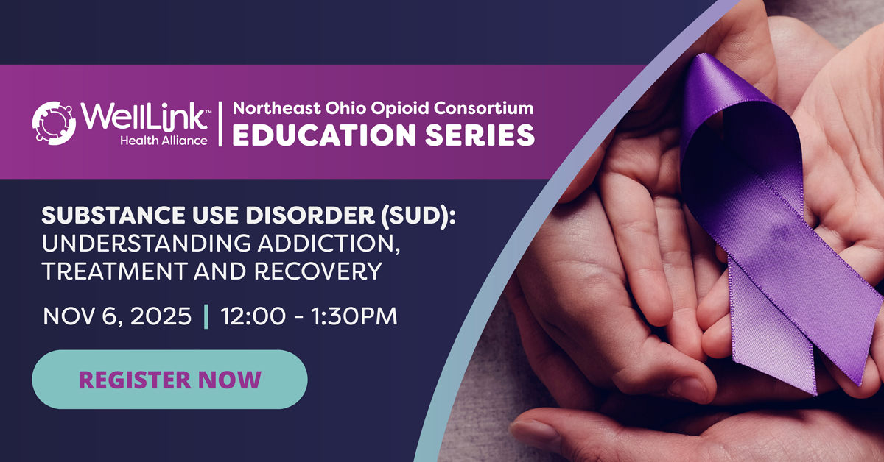

REGISTER TODAY: Northeast Ohio Opioid Consortium Education Series – November 6
Join us on Nov. 6 at 12:00 PM for a Northeast Ohio Opioid Consortium/US Attorney Action Plan Prevention and Education Subcommittee panel discussion providing a comprehensive overview of Substance Use Disorder (SUD) by exploring three key themes:
- Understanding Addiction: Exploring the risks, behaviors, and impact of trauma associated with Substance Use Disorder (SUD).
- Navigating Treatment & Recovery: Outlining the continuum of care, from harm reduction and clinical treatment to community-based support essential for long-term recovery.
- Confronting Community Barriers: Discussing the front-line challenges faced by providers and individuals seeking care in Cuyahoga County.

Register Here

State / Local Updates

  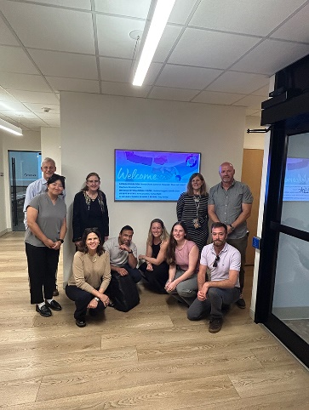
  Northeast Ohio Opioid Consortium Hosts Canadian Delegation to Discuss Strategies Addressing the Opioid Crisis
  On September 26, The Northeast Ohio Opioid Consortium and WellLink hosted the International Visitor Leadership Program delegation from Canada to discuss efforts on both sides of the U.S. Canada border to stem the rise in opioid drug use and overdose. The thoughtful dialogue included sharing best practices and challenges to address the public health crisis caused by opioids and how collaboration across government, law enforcement, and medical field has engaged to curb dependence on opioids.

Governor DeWine Authorizes Ohio Board of Pharmacy to Adopt Emergency Rule Legalizing Tools to Prevent Drug Overdoses
Ohio Governor Mike DeWine signed Executive Order 2025-04D on October 1, 2025 to suspend the normal rulemaking process to allow the Ohio Board of Pharmacy to adopt a rule allowing expanded access to tools to prevent drug overdoses. In addition to test strips and reagent kits for fentanyl, the rule, OAC 4729-8-02, exempts tests for the following compounds from the definition of drug paraphernalia under Ohio law:
- Xylazine;
- Medetomidine;
- Benzimidazole-opioids (commonly referred to as nitazenes); and
- Benzodiazepine and benzodiazepine-related compounds.
Drug test strips and reagent kits serve as crucial tools in harm reduction efforts, allowing users to test substances for the presence of certain substances that are contributing significantly to overdose fatalities.
This rule is made possible by a recent change to Ohio law that was passed by the Ohio General Assembly and signed by Governor DeWine earlier this year. It allows the Board of Pharmacy to exempt certain instruments from the definition of drug paraphernalia if the Board determines the instrument demonstrates efficacy in reducing drug poisoning by determining the presence of a specific compound or group of compounds.
Governor DeWine’s RecoveryOhio Initiative and the Ohio Board of Pharmacy partnered to ensure Ohioans have greater access to lifesaving tools that prevent overdoses. For more information regarding this emergency action, the Ohio Board of Pharmacy developed a guidance document, which can be accessed here: www.pharmacy.ohio.gov/instruments. A quick reference guide is also available by visiting: www.pharmacy.ohio.gov/TestYourDrugs.

2026 Ohio Deflection Association Summit – Register by October 30 for early bird rate.
The Ohio Deflection Association’s annual summit is slated for January 20-23, 2026 in Cincinnati, OH bringing together public safety, behavioral health, and community stakeholders from across the nation. Questions? Contact: admin@ohiodeflectionassociation.org


OneOhio Announced Launch of 2026 Grant Cycle
OneOhio Executive Director Alisha Nelson and Director of Partnership and Outreach Sarah Anstine announced that the Foundation will launch its next grant cycle in December 2025. Lessons from the first grant round and feedback provided through region surveys have been used to streamline Regional Grant Cycle 2 processes and help set clear funding priorities to guide applicants.

OneOhio staff has been working with the 19 OneOhio Regions over the past several months to help them prepare for the next grant round, and that work will continue through November as the Regions establish funding priorities ahead of the Request for Proposals (RFP) release in December. The Foundation will then begin accepting Funding Inquiries in January 2026, with submission reviews expected to start in February.

Anstine also unveiled a new webpage that will serve as the central hub for Regional Grant Cycle 2. This page provides an overview of the upcoming grant process and resources to help applicants prepare for the RFP launch. Additional updates and materials will be posted as they become available. Members of the public should visit OneOhioFoundation.com/Grants to learn more.

LOCAL SPOTLIGHT: Cuyahoga County Overdose Data Dashboard

  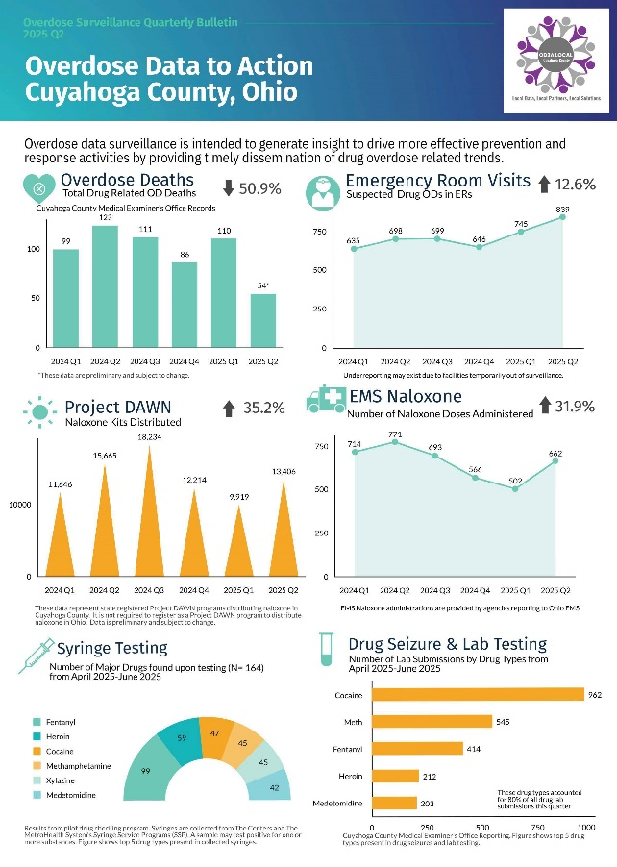
  Access Report Here
  In collaboration with the Begun Center for Violence Prevention Research and Education at Case Western Reserve University and the Cuyahoga County Medical Examiner’s Office, CCBH has developed a data dashboard to disseminate timely, high quality, comprehensive data regarding drug overdoses in Cuyahoga County. The interactive tool contains local data about opioid and other drug overdoses, including those resulting in emergency department visits and deaths, as well as drug prescribing and naloxone distribution and administration data.
  These data are routinely collected, analyzed, and shared to increase understanding of the drug overdose epidemic and inform prevention and response efforts. This application was made possible through the Cuyahoga County Overdose Data to Action Initiative (OD2A) supported by the Centers for Disease Control and Prevention (CDC).

Policy & News Updates
HHS Provides More Than $1.5 Billion in State and Tribal Opioid Response Grants
On September 22, 2025, The U.S. Department of Health and Human Services (HHS), through the Substance Abuse and Mental Health Services Administration (SAMHSA), allocated more than $1.5 billion in FY25 continuation funding awards for the State Opioid Response (SOR) and Tribal Opioid Response (TOR) grants. This funding provides critical resources to states and Tribal communities to address the overdose crisis through prevention, opioid overdose reversal medications, treatment (including medications for opioid use disorder, or MOUD), and recovery support.

"With the rise of polysubstance abuse and increasing role of stimulants in overdose deaths, it has never been more important to comprehensively address the disease of addiction and the root drivers of this crisis," said SAMHSA Principal Deputy Assistant Secretary Dr. Art Kleinschmidt. "State and Tribal Opioid Response funding provides critical resources to help prevent addiction, provide evidence-based treatment, and support long-term recovery and sobriety."

The allocations include $1.48 billion for State Opioid Response and nearly $63 million for Tribal Opioid Response. The Ohio State Department of Mental Health and Addiction Services has been allocated $100,226,750.

Since the SOR program began in 2018, states report that nearly 1.3 million people have received treatment services, including more than 650,000 who received MOUD. Through the SOR program, nearly 1.5 million people have received recovery support services. SAMHSA grantees reported distributing more than 10 million opioid overdose reversal kits, with opioid overdose reversal medications being used to reverse more than 550,000 overdoses. Since the TOR program began in 2018, Tribes report that approximately 16,500 patients have received treatment services, and SAMHSA grantees reported distributing more than 116,500 naloxone kits, with opioid reversal medications being used to reverse more than 1,750 overdoses.

Opioid response grant successes are most evident in qualitative improvements in the lives of participants. At the six-month follow-up, most individuals served through SOR funding reported improved housing stability, social connectedness, health, and employment and education achievement, as well as increased abstinence from alcohol or drug use. For most participants, mental health outcomes also improved, with clients reporting less depression, less anxiety, better behavioral control, and fewer suicide attempts.

Preventing substance misuse, expanding access to treatment, and supporting long-term recovery are key pillars of SAMHSA’s newly released Strategic Priorities. These priorities are foundational to achieving the Administration’s Make America Healthy Again goals.

October is Substance Use & Misuse Prevention Month
Prevention Month lifts up the national conversation — to showcase prevention’s positive effects on communities across the country. Prevention aims to: prevent initiation of substance use, prevent progression of substance use (to a substance use disorder), and prevent consequences associated with substance use. Prevention works by strengthening protective factors and reducing risk factors ― in individuals, families, schools, communities, and society.
Click here to access SAMHSA's Prevention Month Toolkit to help inspire action and showcase prevention’s positive effects on families and communities throughout the nation. This year's theme is "Telling the Prevention Story." The toolkit includes social media shareables, website graphics, flyers, PowerPoint slides, virtual backgrounds, email signatures, and more.
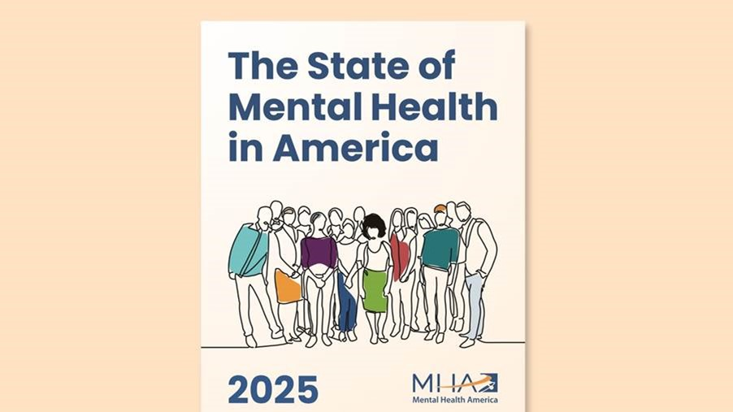

The 2025 State of Mental Health in America Report is here!
Released today, Mental Health America is pleased to share our 2025 State of Mental Health in America Report, which highlights the latest national data and state-level rankings on mental health and well-being in the U.S.

Each year, Mental Health America uses the most recent publicly available federal data to rank all 50 states and the District of Columbia. In this year's report, New York, Hawaii, and New Jersey ranked highest in the nation for mental health – reflecting lower rates of mental illness and higher access to care – while Nevada, Arizona and Alabama ranked lowest.

Key findings from the 2025 report
- Nearly 1 in 4 U.S. adults continue to experience mental illnesses annually.
- The prevalence of mental health concerns among adults in the U.S. remained stable from 2021 to 2024, but these rates are still unacceptably high.
- Access remains a major barrier to care in the U.S.
- Mental health among youth (ages 12-17) in the U.S. improved significantly from 2023 to 2024. Continued support is needed to sustain these trends.
These findings offer critical insights to drive policy, improve care, and support people living with mental health conditions across the country.

This year's report is published in tandem with a youth spotlight on mental health advocacy, created by MHA's Young Leaders Council. This supplemental report shows how young people are already turning awareness into action and provides strategies and inspiration for others to follow. Where did Ohio rank? Explore the full report

Making Sense of Telehealth Changes
Certain federal telehealth flexibilities ended on September 30, 2025, with the expiration of the COVID-19 public health emergency. What does this mean for SUD treatment? This ASAM FAQ has you covered.

Organizations Urge HHS to Not Overburden People with SUD When Implementing New Medicaid Requirements
Twenty-four organizations sent a comment letter to HHS Secretary Robert F. Kennedy, Jr., calling for the agency to allow flexible state implementation of H.R. 1’s “Community Engagement,” or work requirement provisions.

SPRC Releases New Suicide Prevention Resource
The Suicide Prevention Resource Center (SPRC) recently released Pathways to Wellness: Integrating Suicide Prevention in Substance Use Disorder Treatment. This new resource provides guidance on integrating suicide prevention in substance use disorder (SUD) treatment. Designed for SUD treatment professionals, this document may also be useful for other behavioral and mental health clinicians. It highlights the importance, feasibility, and effectiveness of incorporating suicide risk screening and brief interventions in SUD treatment and offers a list of resources to help behavioral health professionals apply effective prevention strategies in their practice. Click here to view the resource.

Training Opportunities
Improving Clinical Practice with Patients who have Opioid Use Disorder: Performance in Practice and Self-Assessment Activity

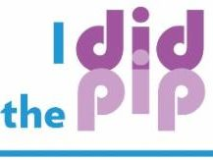

Take the PIP

﻿About the PIP: This PIP activity focuses on the assessment of opioid use disorder (OUD) as well as the offering and monitoring of fundamental aspects of treatment including: patient readiness to change, recommend co-occurring screening (hepatitis A (HAV), hepatitis B (HBV), hepatitis C (HCV), human immunodeficiency virus (HIV) and pregnancy testing), initiating and assessing therapeutic effect of medications for opioid use disorder (MOUD), assessment of potential interacting medications, assessment of comorbid psychiatric illnesses, psychosocial therapy offerings, and overdose risk reduction.

Treatment of Stimulant Use Disorder Course
⏱ 2 CE | 💻Online Course
ASAM has reimagined one of our most popular courses from six hours to two, featuring four unique modules that will ensure you understand the basics of stimulant use disorder (StUD), as well as the recommended treatment, leading you to better prevent overdoses.
Designed for clinicians across settings, you’ll gain:
- Insight into neurobiological and psychological aspects of StUD
- Skills to apply evidence-based behavioral interventions
- Guidance to implement pharmacological treatments effectively
REGISTER HERE - ASAM eLearning: Treatment of Stimulant Use Disorder
Did you know? There are currently no FDA-approved medications for stimulant use disorder (StUD)—but effective treatment options do exist. This course highlights key strategies from the ASAM's Stimulant Use Disorder Guideline (2023) and equips you with practical steps you can apply immediately, from the first patient visit through long-term management.
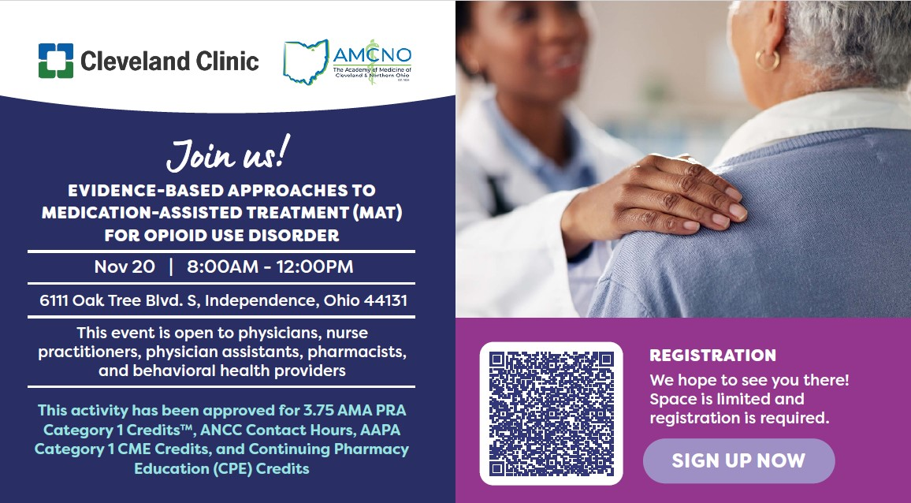
Meet your DEA Requirements: Local MAT Training – Nov 20 | Register here.
View shareable flyer with session information and learning objectives here.
The Ohio Substance Use Disorders Center of Excellence (SUD COE) at Case Western Reserve University's Jack, Joseph, and Morton Mandel School of Applied Social Sciences invites practitioners to deepen their understanding of substance use disorder (SUD) treatment. We are pleased to offer a series of training programs designed to equip professionals with the latest and most effective strategies in SUD treatment. Also, check out the SUD COE website for free trainings (with CEUs!), as well as a wealth of other resources"

CWRU Opioid Response Network (ORN) Trainings
Opioid Response Network (ORN) Trainings | Center for Evidence-Based Practices | Case Western Reserve University

The Opioid Response Network's (ORN) mission is to reduce overdoses and address opioid and stimulant use disorders, and play a key role in tackling the current epidemic. For more information, go to www.OpioidResponseNetwork.org and learn how you and your organization can make a request for free training and education.

  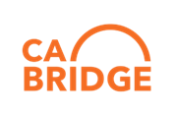
  California Bridge has an online academy with many valuable resources. Their Navigator Training resources are foundational and provide entry level education to explain many different topics.
  Learn more here.

Other Resources

Educational Resources Available WellLink
- Igniting Compassion Documentary
- Igniting Compassion Shorts
- Opioid Consortium Education
- Naloxone Toolkit
- A Clinician’s Guide: Dental Consequences of MOUD + Solutions
- Clinicians Guide: on Xylazine Wound Managerment
- A Clinician's Guide: The Intersection of Human Trafficking and Substance Use Disorders
- NEO Opioid Consortium - Beyond Narcan: Treating Opioid Use Disorder in the Field
- Opioid Roundtable: Using Collaboration to Address the Opioid Crisis in Northeast Ohio
- NEO Opioid Consortium Education Series: Effective Communication with Individuals with SUD
- NEO Opioid Consortium Education Series: Appreciative Approach: From Medical Dominancy to Relational Recovery
- NEO Opioid Education Series: Demystifying Buprenorphine Treatment in the Outpatient Clinic Setting
- NEO Opioid Education Series: Harnessing Health IT to Strengthen Opioid Stewardship
- Previous Issues of The Consortium Chronicle Newsletter
- NEO Opioid Education Series: The Future of Pain Management: Cutting-Edge, Non-Opioid Solutions
- NEO Opioid Consortium Education Series - Chronic Pain: Bridging Clinical Insight & Lived Experience

  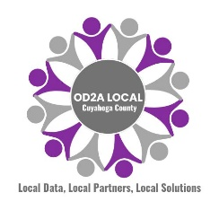
  This newsletter is supported by the CDC OD2A LOCAL Grant to the Cuyahoga County Board of Health.

 |  |  | 

1226 Huron Road East, Cleveland, OH 44115

