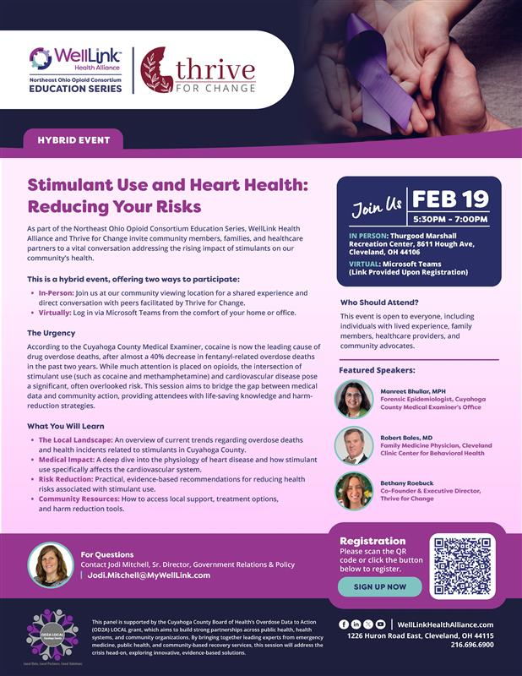

Upcoming Hybrid Event: February 19, 2026 | See info below and register here.
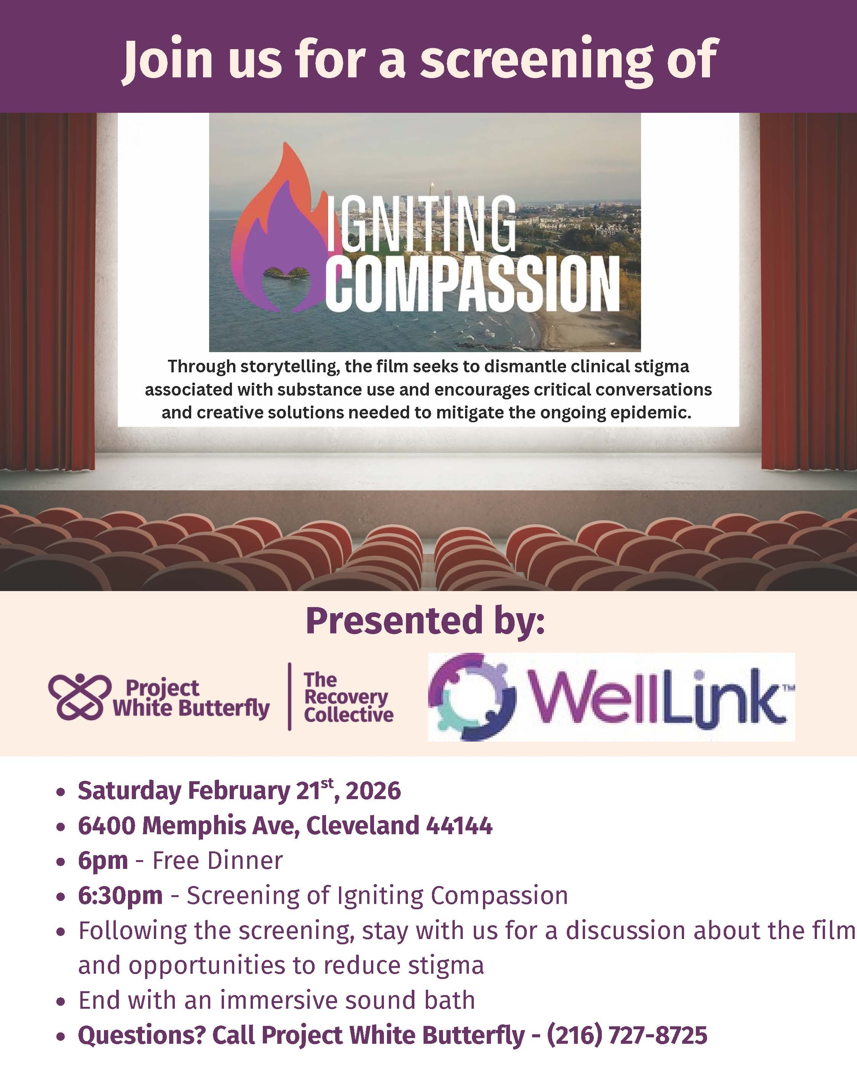

  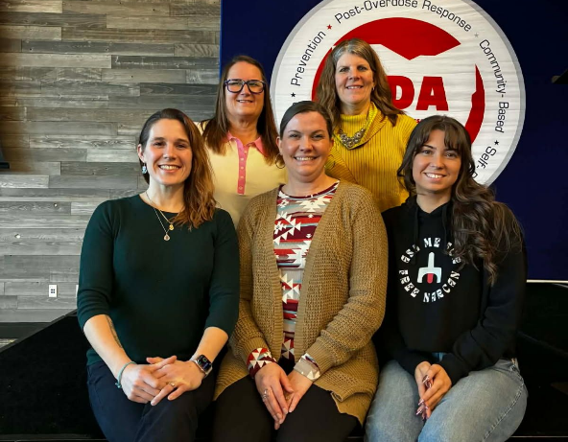
  Igniting Compassion Screening at Ohio Deflection Association Conference
  On January 22, the Northeast Ohio Opioid Consortium and WellLink facilitated a screening of Igniting Compassion at the Ohio Deflection Association annual conference in Cincinnati. Joining WellLink wereProject White Butterfly, Thrive for Change, and the Woodrow Project.

Human Trafficking and Substance Use Disorder Webinar Recording Available
On Jan 22, 2026, the Northeast Ohio Opioid Consortium hosted its education series event on Human Trafficking and Substance Use Disorder with Kristin Hess, RN from MetroHealth's Office of Opioid Safety. A recording is available HERE.

WellLink Launches SPEAK Bureau
Substance Use Prevention, Education, Advocacy & Knowledge (SPEAK) Bureau is a collaborative training and technical assistance network facilitated by Northeast Ohio Opioid Consortium. Our mission is to connect organizations across Northeast Ohio with leading local experts to expand knowledge, enhance skills, and improve service delivery on complex and emerging issues in polysubstance use and substance use disorder treatment and recovery. We serve as a centralized resource for organizations seeking customized, expert-led education to better address the challenges of substance use in our community. The types of groups and organizations we hope to connect to this form of education include hospitals, clinics, social service agencies, nonprofits and more. Access SPEAK here.

State / Local Updates

Cuyahoga County’s leading overdose killer is now cocaine. How do we treat it?
The county's Medical Examiner is calling to pivot addiction prevention and treatment efforts to address rising cocaine overdose deaths, but experts say it could be tricky, because they don't have the same kind of tools for stimulants as they do opioids. Click HERE for the Cleveland.com article.

OHA Opioid Overdose Dashboard Updated with Q3 2025 Data
OHA’s Opioid Overdose Dashboard has been updated with data through the third quarter of 2025. The data is derived from the more than 39 million annual coded hospital encounters in Ohio. The release of per-capita rates by county as well as by market area are intended to assist health policymakers, funders and local collaboratives in their work.

Q3 2025 saw 1,372 overdose encounters, a slight decrease from 1,397 in Q2 2025. The data does not reflect overdoses that did not present for care at a hospital or overdoses that occurred among Ohio residents who were cared for at hospitals outside the state. Learn more about OHA’s Opioid Stewardship initiative here.

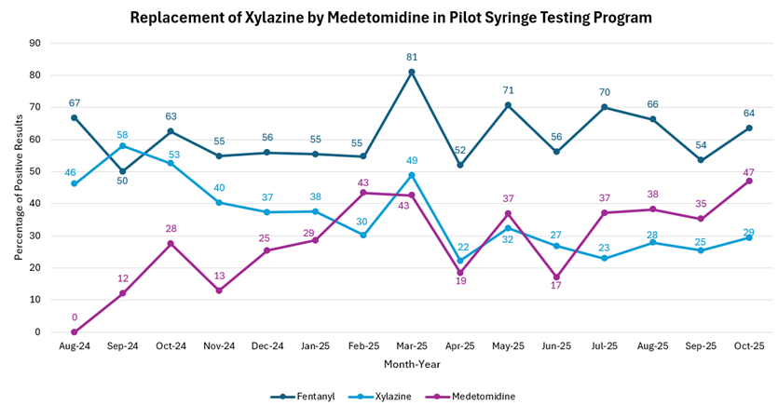

Cuyahoga County's pilot drug checking program began testing syringes in August of 2024. This graph reports the percentage of positive samples of fentanyl - the most common drug detected in the syringes, xylazine and medetomidine. Xylazine and medetomidine are both sedatives used in veterinary medicine, with similar structures. However, it is reported that medetomidine causes severe withdrawal that does not respond to conventional treatment protocols, and Xylazine is associated with skin wounds. It is important to continue to monitor these adulterants in the drug supply, as data from Cuyahoga County's pilot drug checking programs shows a decrease in Xylazine, and subsequent increase in Medetomidine in 2025.

Ohio Suicide Prevention Foundation AI Resources
The Ohio Suicide Prevention Foundation has recently published two resources titled The Intersection of AI & Mental Health and Artificial Intelligence 101: A Guide for Parents. AI tools are increasingly used in mental health care and in teens’ daily lives, offering new ways to support well-being and improve access to services. At the same time, they raise ethical and safety concerns, including bias, privacy risks, exposure to harmful content, and overreliance that may affect professional care, social development, or sleep habits. Experts stress the importance of clear standards and oversight, while parents play a key role by setting boundaries, monitoring use, and co-exploring AI with their children to ensure these tools support mental wellness safely and equitably.

Click the links below to access the publications:
The Intersection of AI & Mental Health
﻿Artificial Intelligence 101: A Guide for Parents

Ohio Recovery Friendly Workplace
Supporting employees in their recovery journey by becoming a recovery-friendly workplace benefits everyone. It not only aids your team but also improves your bottom line, boosts productivity and reduces turnover. To explore becoming an Ohio Recovery Friendly Workplace, review the benefits to your organization, discover practical steps to foster a supportive environment and get a designation through the Ohio Department of Behavioral Health. Click HERE for more information.

LOCAL SPOTLIGHT
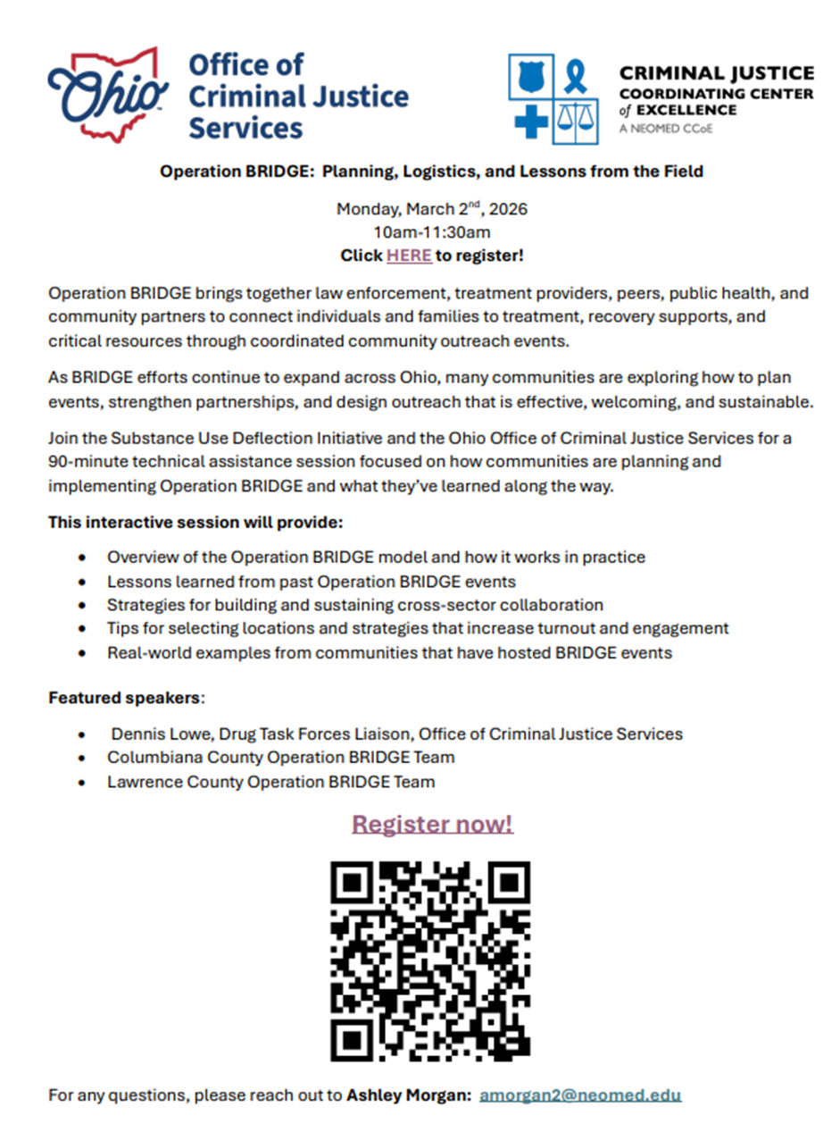

Policy & News Updates
Miller-Meeks’ Bipartisan Alternatives to PAIN Act Surpasses 70 Cosponsors, Gaining Momentum in Congress

Reps. Hurd, Tran, Dean Introduce Bipartisan Legislation to Combat Youth Substance Use

Advocacy Opportunities:
- Tell Congress to support our Veterans and pass the NOPAIN for Veterans Act (S. 3209/H.R. 4509)! Click here
- Help Medicare patients avoid opioid addiction. Urge Congress to pass the Alternatives to PAIN Act (S. 475/H.R. 1227)! Click here.
Trump Launches the Great American Recovery Initiative to Address the Addiction Crisis
President Trump signed an Executive Order (EO) creating “the White House Great American Recovery Initiative to coordinate a national response to the disease of addiction across government, healthcare, faith communities, and the private sector in order to save lives, restore families, strengthen our communities, and build the Great American Recovery.” Additionally, HHS Secretary Robert F. Kennedy, Jr. announced $100 million to solve long-standing homelessness issues, fight opioid addiction, and improve public safety by expanding treatment that emphasizes recovery and self-sufficiency.

According to the White House Fact Sheet, addiction affects tens of millions of Americans and imposes major social and economic costs. This initiative signals renewed federal coordination, potential policy changes, and funding priorities that could shape healthcare delivery, public health programs, and regulatory engagement with providers and community partners. Additionally, the HHS Office for Civil Rights (OCR) issued an updated Fact Sheet 42 CFR Part 2 Final Rule in recognition of Substance Use Disorder Treatment Month. It notes that, “Persons subject to the regulation must comply with the applicable requirements of the final rule by Feb. 16, 2026.”

Funding Bill Signed into Law – Funding for Combatting the Opioid Epidemic and Mental Health
Combatting the Opioid Epidemic: $1.6 billion for the State Opioid Response Grants; $1.9 billion for the Substance Use Prevention, Treatment, and Recovery Services Block Grant; and $145 million for the Rural Communities Opioid Response program to support efforts to combat the opioid epidemic and other substance use disorders. Funding provided in the bill will also support strengthening the workforce, especially in rural communities, and expanding research for critical needs, such as funding alternative pain medications.

Mental Health: More than $5.5 billion for mental health research, treatment, and prevention, including:
- $535 million for the Substance Abuse and Mental Health Services Administration (SAMHSA) suicide prevention Lifeline, 9-8-8.
- $386 million for Certified Community Behavioral Health Clinics.
- $2.2 billion for the National Institute of Mental Health.
- $1 billion for the Mental Health Block Grant.
- $164 million for school-based mental health grants at the Department of Education.

Nearly 1 million Americans over 65 are living with opioid addiction, a fast-growing and often overlooked population.
In their latest episode, Tradeoffs goes inside a Baltimore methadone clinic that’s finding creative ways to go the extra mile for this group of vulnerable patients, combining addiction treatment with support for complex health and social needs, including diabetes, heart failure, and housing insecurity. Check out the story to learn more about what comprehensive, patient-centered addiction care can achieve — and what’s at stake. A Better Way to Care for Older Adults with Opioid Addiction - Tradeoffs

DEA Recognizes its Success in Combatting Drug Cartels and Saving Lives
According to a DEA Release on February 3, 2025 was a year of historic achievements for the U.S. Drug Enforcement Administration highlighted by significant drug seizures, the capture of high-profile targets, and the confirmation of DEA Administrator Terrance C. Cole. DEA’s focus on dismantling Mexican drug cartels, disrupting chemical supply chains, and reducing violence in cities across America in 2025 resulted in the seizure of:
- 47 million fentanyl pills
- 9,938 pounds fentanyl powder
- 567,668 pounds cocaine
- 172,853 pounds methamphetamine
- 2,700 pounds heroin
The amount of fentanyl seized this past year is equivalent to 369 million potential lives saved.

DEA launched Fentanyl Free America in October. This comprehensive enforcement initiative and public awareness campaign aims to reduce both the supply and demand for fentanyl. This effort underscores DEA's unwavering commitment to protecting American lives and communities from the devastating impacts of fentanyl, which claimed more than 50,000 lives in 2024 according to the Centers for Disease Control and Prevention (CDC), a sharp decrease from nearly 80,000 lives in 2023. This is welcome progress in the fight against fentanyl.

Stigma reduction resources
The American Hospital Association actively works to combat behavioral health stigma through promoting the use of patient-centered language, supporting integrated care models and encouraging open dialogue about mental health and substance use disorders in health care settings. Programs and policies that actively aim to reduce stigma have been shown to positively impact treatment outcomes for both patients and health care workers who need behavioral health support.
- Shatterproof Addiction Stigma Index
- AHA Blog: We must better understand stigma toward patients with substance use disorders
- Opioids and Stigma
New Resources Available to Support Implementation of the NOPAIN Act
The NOPAIN Law mandates that Medicare provide additional reimbursement for qualifying non-opioid options across hospital outpatient departments and ambulatory surgical centers. The NOPAIN Act increases patient and provider access to non-opioid pain management options to manage postsurgical pain by removing barriers associated with reimbursement. Providers can now provide certain qualifying non-opioids to your Medicare patients to help manage their pain without relying solely on prescription opioids. The product must be FDA-approved to reduce postoperative pain or produce postsurgical or regional analgesia and not act on the body’s opioid receptors.

The NOPAIN law should result in increased accessibility and adoption of qualifying non-opioid products to help tailor pain management, reduce opioid exposure, and support safe recovery. Reimbursement is now clear and consistent. Fact sheets for clinicians, patient/families, individuals in recovery, etc are available HERE.

  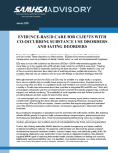
  Advisory: Evidence-Based Care for Clients with Co-Occurring Substance Use Disorders and Eating Disorders
  This advisory addresses the relationship between eating disorders and substance use disorders—as well as issues related to co-occurrence of the disorders. The advisory provides health care practitioners with the tools needed to implement evidence-based, integrated, person-centered care—all with the aim of helping individuals with these co-occurring disorders to attain and retain recovery.
  Read More

  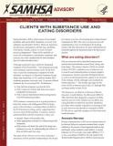
  Clients With Substance Use and Eating Disorders
  This advisory equips substance use treatment and service providers with information about eating disorders and their relationship to substance use disorders. It provides an overview of screening, referrals, and evidence-based treatments for eating disorders and lists resources for more information.
  https://library.samhsa.gov/product/clients-substance-use-and-eating-disorders/sma10-4617

  Integrating Substance Use Disorder Prevention with Physical Health Care: Progress in States SAMHSA recently released a new publication, Integrating Substance Use Disorder Prevention with Physical Health Care: Progress in States. This report explores how states are working to integrate SUD prevention into physical health care settings, particularly for adolescents. Expanding access to Preventing substance misuse, abuse, and addiction is one of the core strategic priorities for SAMHSA. Prevention is essential to avoid this chronic disease, and to improve public health. Integrating SUD prevention with physical health care is an effective strategy.
  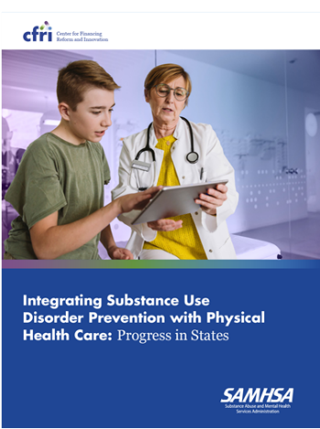

  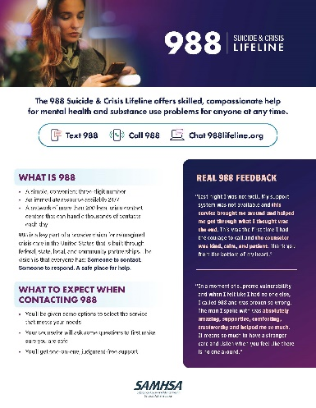
  988 Fact Sheet
  The refreshed 988 Fact Sheet is now available in the SAMHSA 988 Partner Toolkit.
  This updated version offers an easy-to-share overview of what 988 is and what people can expect when contacting 988. It also features testimonials from people who have used 988, along with answers to frequently asked questions.

  988 & 911 Fact Sheet and Social Media
  Many people have questions about the difference between 988 and 911. We now have dedicated resources to help address them. The new 988 & 911 Key Difference Fact Sheet provides a high-level overview to support clear communication about when each service is the right fit. Complementary social media assets are also available in the 988 Partner Toolkit, making it easy to share accurate information across your channels.
  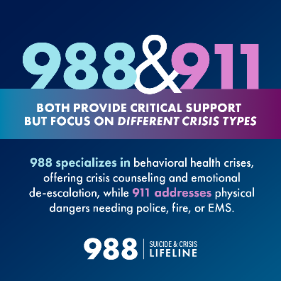

Guidance for Investing the Opioid Settlement Funds
Communities across the country are deciding how to use opioid settlement funds and have an opportunity to invest in prevention today to protect future generations. Partnership to End Addiction is pleased to share a new resource, Guidance for Investing the Opioid Settlement Funds in Primary Prevention, to help communities and leaders make informed, evidence-based decisions that strengthen prevention efforts. The guide summarizes the research on effective prevention strategies, highlights approved uses in the Settlement Agreement aligned with primary prevention and showcases real-world examples from states and communities already investing the funds in primary prevention-aligned strategies.
Training Opportunities
WellLink Launches SPEAK Bureau
Substance Use Prevention, Education, Advocacy & Knowledge (SPEAK) Bureau is a collaborative training and technical assistance network facilitated by Northeast Ohio Opioid Consortium. Our mission is to connect organizations across Northeast Ohio with leading local experts to expand knowledge, enhance skills, and improve service delivery on complex and emerging issues in polysubstance use and substance use disorder treatment and recovery. We serve as a centralized resource for organizations seeking customized, expert-led education to better address the challenges of substance use in our community. The types of groups and organizations we hope to connect to this form of education include hospitals, clinics, social service agencies, nonprofits and more. Access SPEAK here.

Medetomidine withdrawal occurs within 2 hours of last use and presents with refractory vomiting and tremors, and is complicated by severe hypertension and tachycardia. Check out this fact sheet for a quick overview of medetomidine.

Listen to ASAM Practice Pearl's
Season 2 Premiere: Understanding Medetomidine: Emerging Challenges
for Addiction Medicine

  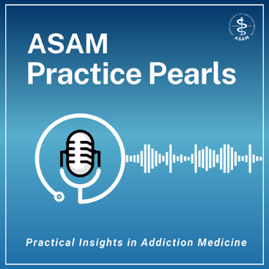
  ASAM Practice Pearls features in-depth discussions on addiction prevention, treatment, and recovery. This series explores the latest evidence-based approaches to addiction medicine. Listen to interviews with leading experts as they delve into critical topics and share practical tools you can use to improve patient care and promote public health.
  Recent Episodes:
  - Overdose Awareness: Preventing, Responding, and Intervening
  - Perinatal Substance Use Care: Listening, Trust, and Treatment
  - Listening First: The Future of Women's Addiction Treatment
  Listen Here - ASAM Practice Pearls | ASAM Education

Optimizing Opioid Overdose Response: Compassion During Crisis
Monday, February 23, 2026 | 4:00pm - 5:30pm ET
FREE Live-Virtual Course
This 90-minute course equips healthcare professionals with the essential knowledge, skills, and confidence to educate patients, families, and caregivers about opioid overdose prevention and response, including naloxone use. The course provides comprehensive knowledge of overdose risk factors, overdose recognition, and overdose response. Person-centered, non-stigmatizing communication is emphasized to improve confidence and effectiveness in discussing harm reduction and overdose prevention. By the end of the course, learners will be equipped to integrate overdose prevention strategies into their everyday practice, effectively and compassionately manage overdose events, promote harm reduction, and contribute to improved patient safety and outcomes across various healthcare settings

The target audience for this introductory level activity includes: Physicians, advanced practice practitioners, nurses, dentists, medical assistants, social workers, peer recovery specialists, and other healthcare professionals across diverse care settings, seeking to lead overdose prevention efforts. Click HERE for Registration.

The Ohio Substance Use Disorders Center of Excellence (SUD COE) at Case Western Reserve University's Jack, Joseph, and Morton Mandel School of Applied Social Sciences invites practitioners to deepen their understanding of substance use disorder (SUD) treatment. We are pleased to offer a series of training programs designed to equip professionals with the latest and most effective strategies in SUD treatment. Also, check out the SUD COE website for free trainings (with CEUs!), as well as a wealth of other resources"

Clinical QuickNotes on Substance Use Disorders
The Ohio Substance Use Disorders Center of Excellence (SUD COE) has developed “Clinical QuickNotes on Substance Use Disorders” as a tool to provide busy treatment providers with quick overviews of clinically relevant topics. These QuickNotes are designed to be easily digestible, offering essential information that can be reviewed in just a few minutes. Check out each topic below!
- Cannabis and Mental Health: Navigating Clinical Realities in Ohio
- Treating Opioid Use Disorder During Pregnancy and the Postpartum Period
- Medications for Opioid Use Disorder (MOUD) in Adolescents and Young Adults
- What’s Happened with Alcohol Use Disorder?
- Ohio Medical Board Amends Rules for Medication Treatment of Opioid Use Disorders
- Responding to Provider Trauma, Grief, and Loss Following Unintentional Lethal Overdose
- Family Grief and Loss Experiences Following Unintentional Lethal Overdose
The Opioid Response Network's (ORN) mission is to reduce overdoses and address opioid and stimulant use disorders, and play a key role in tackling the current epidemic. For more information, go to www.OpioidResponseNetwork.org and learn how you and your organization can make a request for free training and education.
- Hot Topics - On-Demand - AOAAM Learning Portal

  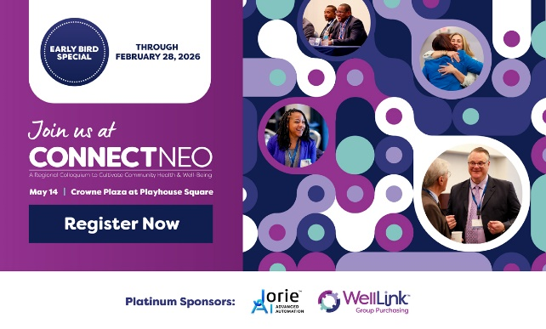
  Register Here
  ConnectNEO 2026 Early Bird Registration is now open!
  Save on tickets now through Feb. 28 to WellLink's annual conference with code EARLYBIRD26. The conference will be held at the Crowne Plaza Cleveland at Playhouse Square on May 14, and we're excited to be introducing breakout sessions this year for attendees to customize their day to include sessions that will be most meaningful. Will we see you there?

Other Resources

Educational Resources Available from WellLink
- Igniting Compassion Documentary
- Igniting Compassion Shorts
- Opioid Consortium Education
- Naloxone Toolkit
- A Clinician’s Guide: Dental Consequences of MOUD + Solutions
- Clinicians Guide: on Xylazine Wound Managerment
- A Clinician's Guide: The Intersection of Human Trafficking and Substance Use Disorders
- NEO Opioid Consortium - Beyond Narcan: Treating Opioid Use Disorder in the Field
- Opioid Roundtable: Using Collaboration to Address the Opioid Crisis in Northeast Ohio
- NEO Opioid Consortium Education Series: Effective Communication with Individuals with SUD
- NEO Opioid Consortium Education Series: Appreciative Approach: From Medical Dominancy to Relational Recovery
- NEO Opioid Education Series: Demystifying Buprenorphine Treatment in the Outpatient Clinic Setting
- NEO Opioid Education Series: Harnessing Health IT to Strengthen Opioid Stewardship
- Previous Issues of The Consortium Chronicle Newsletter
- NEO Opioid Education Series: The Future of Pain Management: Cutting-Edge, Non-Opioid Solutions
- NEO Opioid Consortium Education Series - Chronic Pain: Bridging Clinical Insight & Lived Experience
- NEO Opioid Consortium Education Series: SUD Understanding Addiction, Treatment & Recovery

  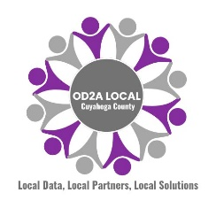
  This newsletter is supported by the CDC OD2A LOCAL Grant to the Cuyahoga County Board of Health.

 |  |  | 

1226 Huron Road East, Cleveland, OH 44115

